Step 1: Create Dynamic Web Project
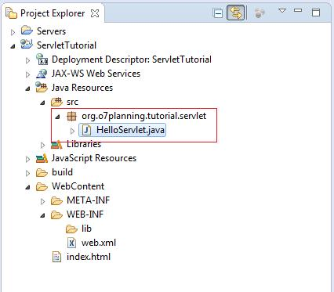
1. Create project
- Open Eclipse.
- Click File → New → Dynamic Web Project.
- Project name: CookieProject
- Target Runtime: Apache Tomcat v10.1
- Click Next → Next → Finish.

2. Create package
- Expand CookieProject.
- Right-click Java Resources → src.
- Select New → Package.
- Package name: com.cookie
- Click Finish.

3. Create Java class
- Right-click com.cookie.
- Select New → Class.
- Class name: CookieServlet
- Click Finish.
- Paste the corrected code from Step 1 and press Ctrl + S.
Step 3: Start Tomcat server
- Click Window → Show View → Servers.
- Find Tomcat v10.1 Server at localhost.
- Right-click it and select Start.
- Wait until the server status changes to Started.
If Tomcat is not configured, first add it through File → New → Other → Server → Apache → Tomcat v10.1.
Step 4: Run the program
- Right-click CookieServlet.java.
- Select Run As → Run on Server.
- Select Tomcat v10.1 Server.
- Click Finish.

package com.cookie;

import java.io.IOException;
import java.io.PrintWriter;

import jakarta.servlet.ServletException;
import jakarta.servlet.annotation.WebServlet;
import jakarta.servlet.http.Cookie;
import jakarta.servlet.http.HttpServlet;
import jakarta.servlet.http.HttpServletRequest;
import jakarta.servlet.http.HttpServletResponse;

@WebServlet("/cookie")
public class CookieServlet extends HttpServlet {

private static final long serialVersionUID = 1L;

@Override
protected void doGet(HttpServletRequest request,
HttpServletResponse response)
throws ServletException, IOException {

response.setContentType("text/html;charset=UTF-8");
PrintWriter out = response.getWriter();

Cookie nameCookie = new Cookie("username", "Balaji");
Cookie courseCookie = new Cookie("course", "JavaEE");

nameCookie.setMaxAge(60 * 60);
courseCookie.setMaxAge(60 * 60);

response.addCookie(nameCookie);
response.addCookie(courseCookie);

out.println("<html><body>");
out.println("<h2>Cookies Created Successfully</h2>");

Cookie[] cookies = request.getCookies();

if (cookies != null) {
out.println("<h3>Available Cookies:</h3>");

for (Cookie cookie : cookies) {
out.println("<b>Name:</b> " + cookie.getName()
+ " &nbsp; <b>Value:</b> " + cookie.getValue()
+ "<br>");
}
} else {
out.println("<p>No cookies found.</p>");
}

out.println("</body></html>");
}
}

